

Programming Paradigms BCS 222-2

Project 2 -Automated Medical Appointment Booking Assistant

# | ID | Name | Code & Report(15) | Individual Q&A(5) | Total(20)
1 | 20230003918 | Hans Misquitta
2 | 20230003374 | Badr Arabi
3 | 20220002085 | Hassan Mutajba
4 | 20210001826 | Majed Alzenati

Description:
This projects focus is to develop a booking system for medical appointments to aid those who find difficulties in navigating through websites. The system is built for users such as the elderly, and those that may be physically impared.

Technology:
Through the use of Python and Lisp an application has been developed to display a simplified GUI using Streamlit to allow users to enter their profile details. After doing so, the program will save the data into an env file and utilize that as well as AI such as Gemini to navigate through websites and apply for the user. This application was created to develop an easier path to applying for medical appointments. When it comes to medical issues, it is neccessary to incorporate as many paths as possible to allow users access in different situations, for health is a major priority and should take precedence as much as possible.

Streamlit will be used to develop the frontend, the interface that the user will interact with to enter profile details. For the backend Python as well as Lisp will be relied upon to make the transition smooth. Gemini 2.0 has been chose as the model for this project, though it is not restricited to it, flexibilty and versatility are important details that need to be taken into account to accomadate different hardware and connections of users. Lisp has been integrated for simple decision logic to help improve efficency.

Programming Paradigms covered:
Impreative programming – Reading env and providing commands to the computer through Python.
Object-Oriented programming – Utilizing browseruse and agent to access their libraries are required to create custom tasks to be followed.
Functional programming – Lisp has been relied on through functions to cover basic error handling in case of incorrect user input.
Interactive programming – Streamlit reacting to user input in real time, providing a seamless experience, allowing higher efficiency.

Challenges faced:
Many difficulties were faced during implementation, such as the AI model struggling to recognize parts of the website, tasks being followed incorrectly as well as hardware struggling to keep up. All these issues will be resolved as AI models continue to grow and more testing has been completed.

Env file:

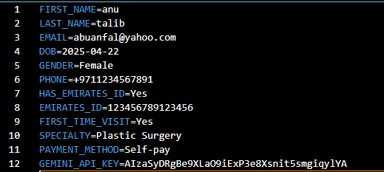

The image above showcases sample data that will be stored in the env file, which is then utilized by the AI agent to complete the task at hand.

Program:
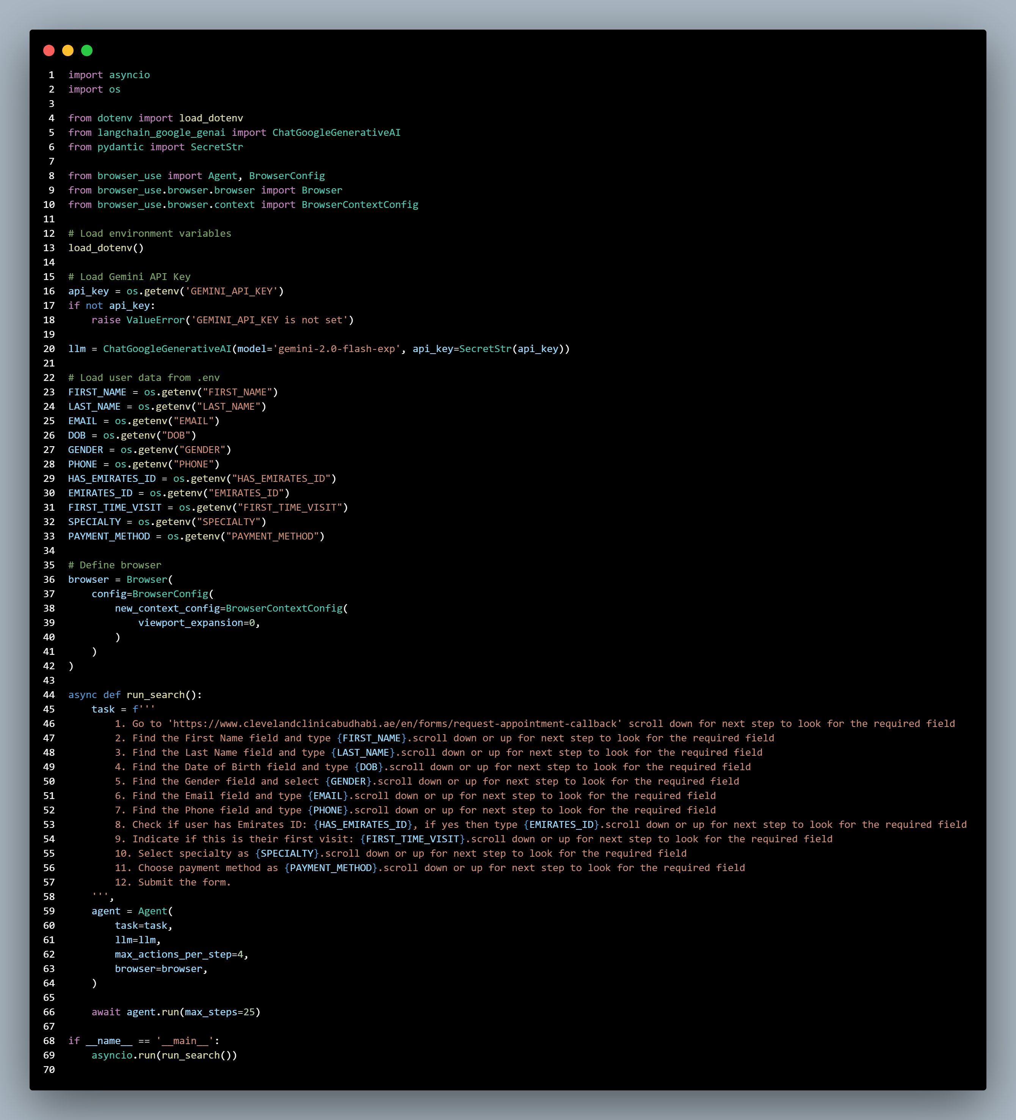
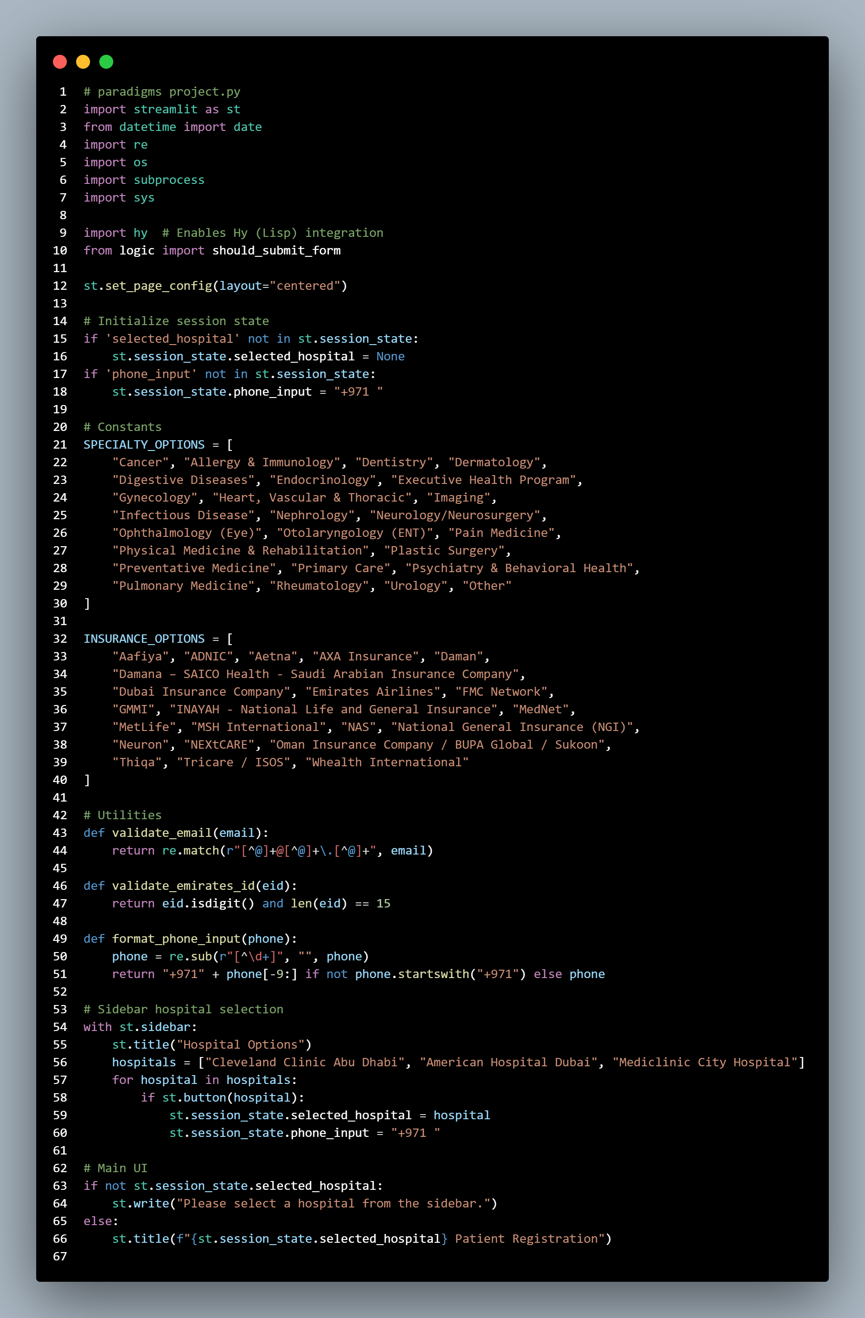
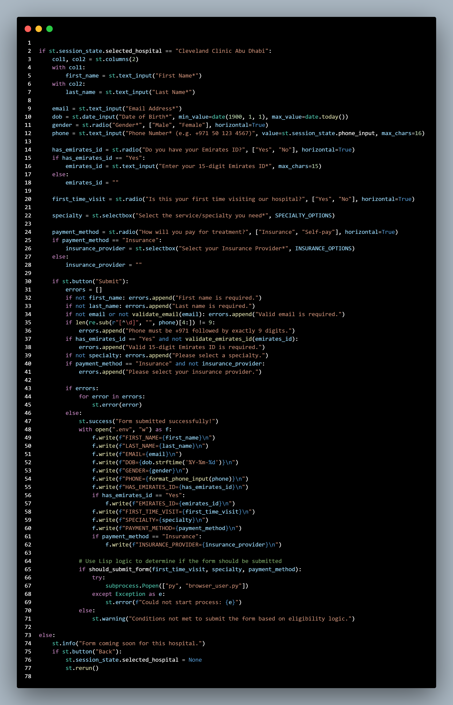
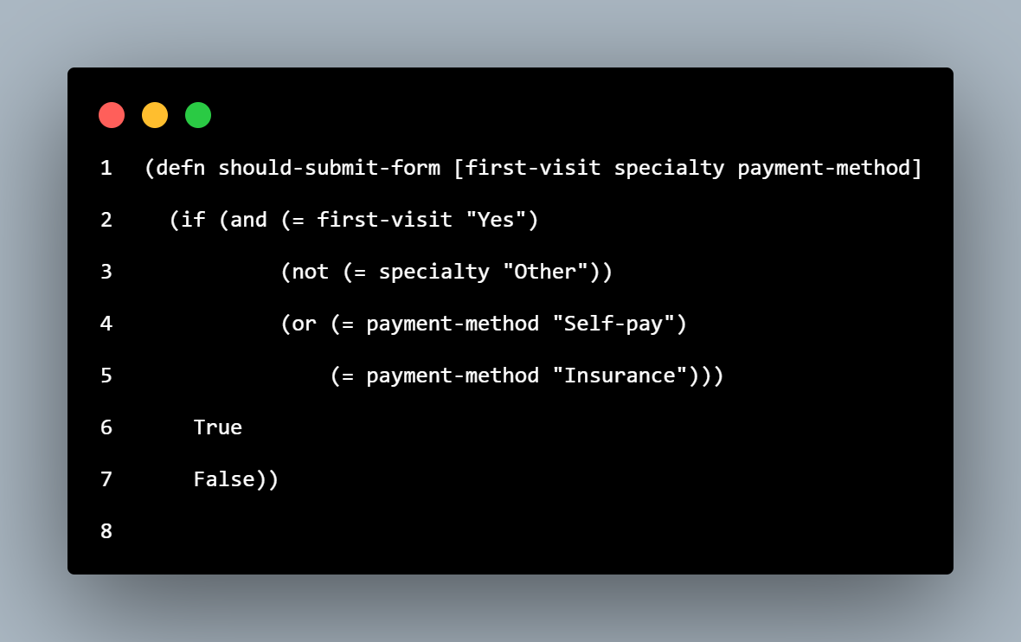
The 4 images listed above display the code utilized to create the application. The first image paradigms project py contains the data for the ui in response to the user. The next 2 images contains the utility of the AI agent and the tasked prompt. While the final image showcases LISP utilized to handle error handling for specific details in the User interface.

Output:
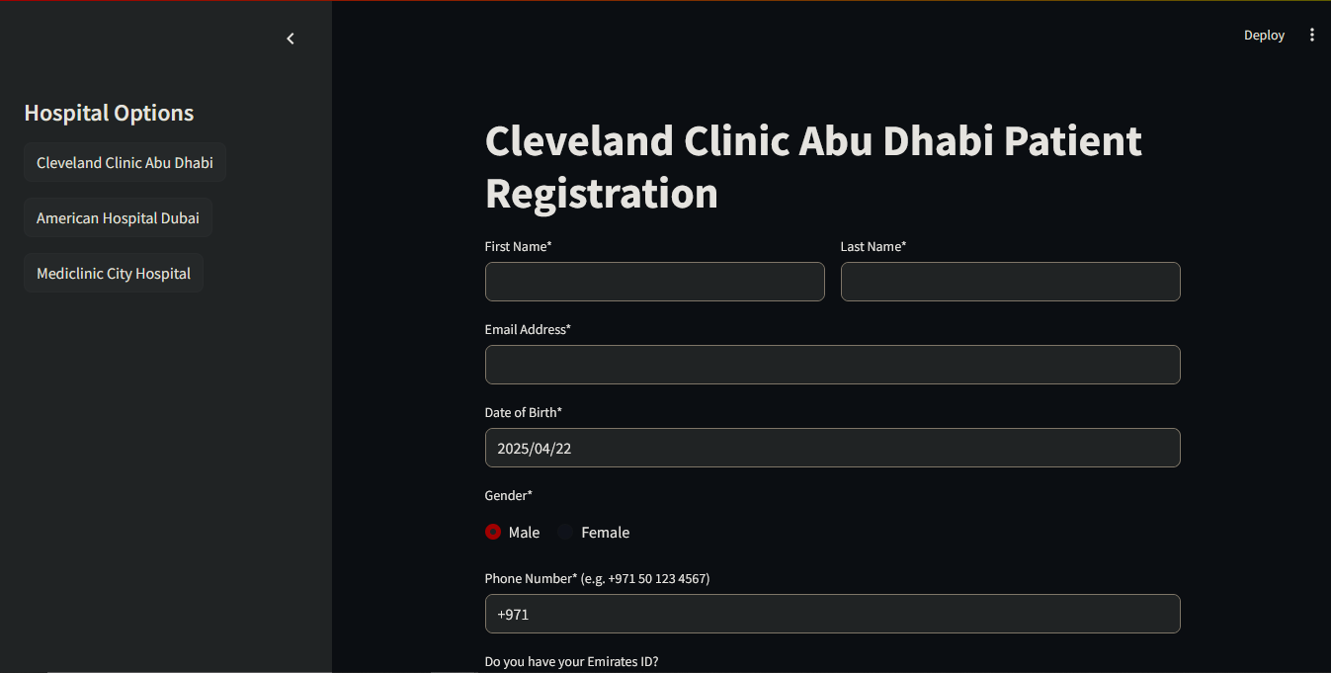
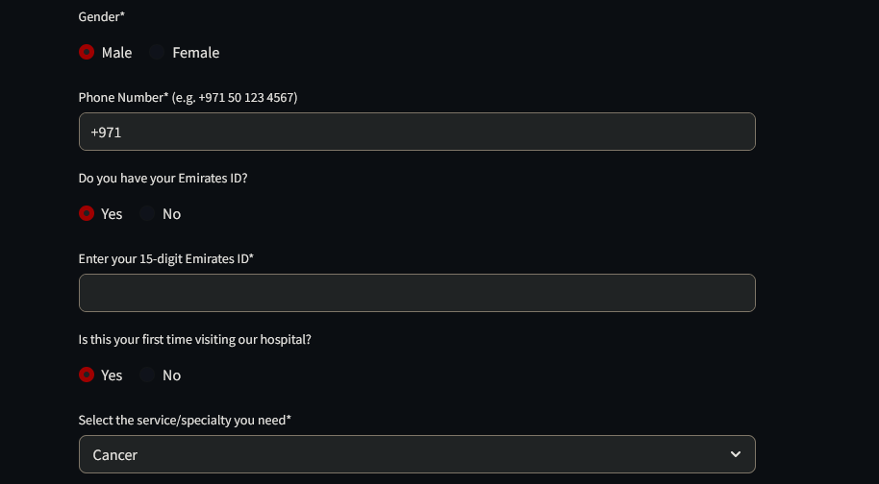
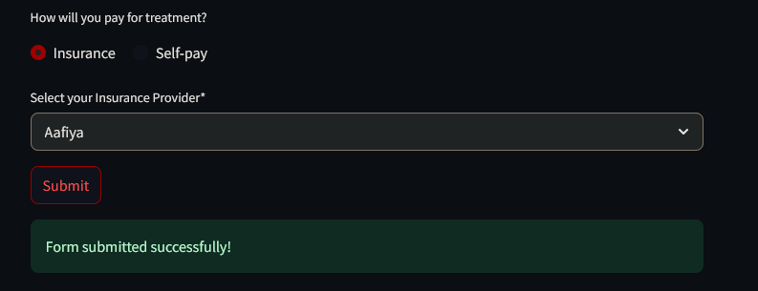
Listed above are images showcasing the GUI displayed by Streamlit as well as the success message. The GUI reacts different based on each option, for emails and numbers it ensures that no irregular input is accepted, which helps the user to confirm whether they have mentioned the correct data.
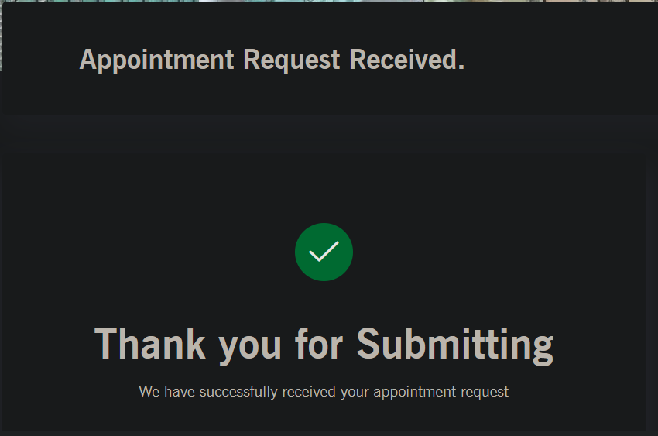
Above displays the expected image from a sample website, where the form has been filled successfully.
Conclusion:
Through this project, we hope to influence others to develop better applications with accessibility in mind, to ensure that all users regardless of age, technical expertise will have the means to get the attention they require.

